3.5 inch ESP32 module

List

Product description 3

Features 3

Product parameters 4

Interface Description 5

Product Size 6

3. 5寸 ESP32-035 第 2 页 共 5 页

Product description
This LCD module uses ESP32-WROOM-32 module as the main control, the main control is a dual-core MCU, integrated WI-FI and Bluetooth functions, the main frequency can reach 240MHz, 520KB SRAM, 448KB ROM, Flash size is 4MB, The display resolution is 320X480, resistive touch. The module includes LCD display screen, backlight control circuit, touch screen control circuit, speaker drive circuit, photosensitive circuit and RGB-LED control circuit. TF card interface, serial interface, temperature and humidity sensor interface (DHT11 interface) and reserved IO port interface, this module supports development in arduino IDE, ESP IDE, Micropython and Mixly.

Features

●3. 5-inch color screen, support 16 BIT RGB 65K color display, display rich

colors

●320X480 resolution

●The sample program has been programmed in the factory and can be plugged in
●With TF card slot for easy expansion storage

●Provide arduino library functions and sample programs to facilitate rapid secondary development
●Support one-click download program

●Military-grade process standards, long-term stable work

●Supports lithium battery power supply, supports both charging and discharging, and has over charging and over discharging protection
3. 5寸 ESP32-035 第 3 页 共 5 页

Product parameters

Name | Describe | Remark
Display color | RGB 65K color
SKU | without touch：ESP32-035
Size | 3. 5 inch
Type | TFT
Driver chip | ST7796
Resolution | 320*480(Pixel)
Effective display area | 55.2*85(mm)
Module size | 55.34*101.5(mm)
View | >60 °
Operating temperature | -20℃~70℃
storage temperature | -30℃~80℃
Operating Voltage | 5V
Power consumption | About 100mA
Product weight | About 40g

3. 5寸 ESP32-035 第 4 页 共 5 页

Interface Description

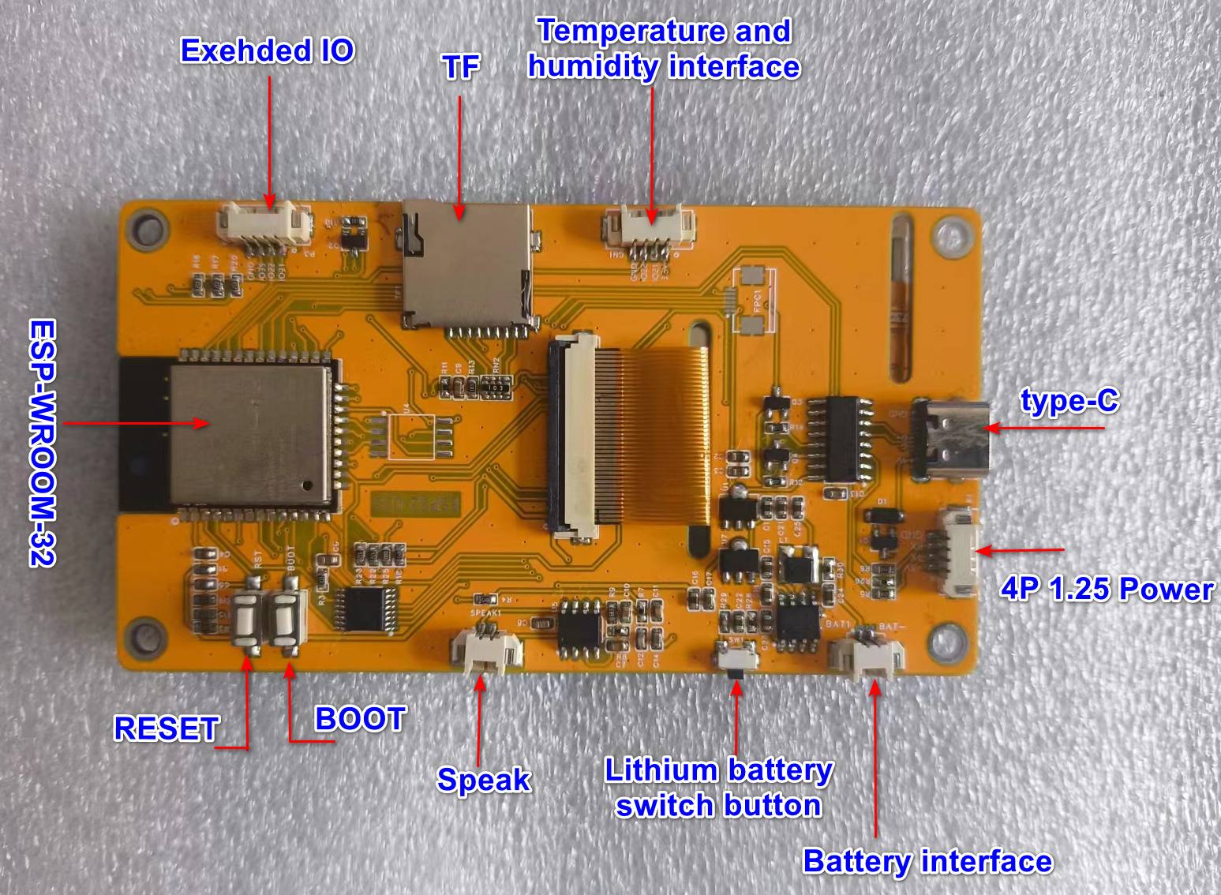

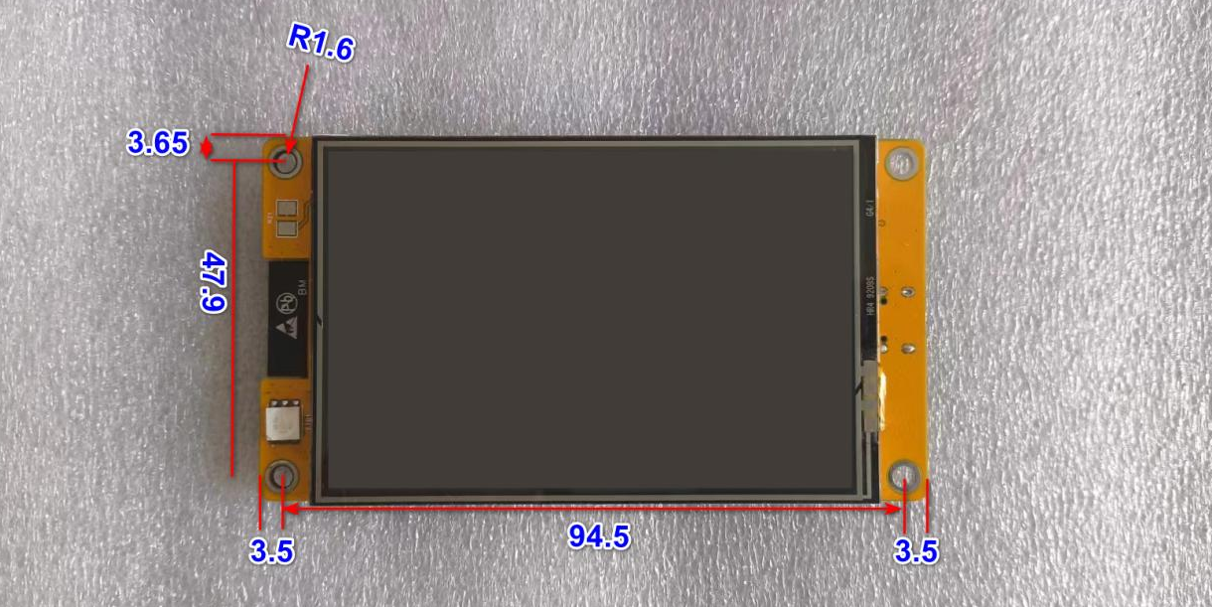

3.5寸 ESP32-035 第 5 页 共 5 页

